Architecture Diagram for Symbiosis case study

App URL => <http://sample-node-app-alb-1575548733.us-east-2.elb.amazonaws.com/>

VPC with two subnet in multi-AZ with RDS with multi AZ switched on.

Bastion host for System admins to login to instance in private subnet.

NAT in public subnet

Classical Load Balancer behind Internet Gateway. Automatic scaling works behind the Classic Load Balancer.

Public 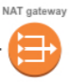

Subnet

Private 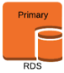

Subnet

AZ 1 

Web Server

Users

  

AZ 2 

Private 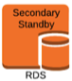

Subnet

Public 

Subnet